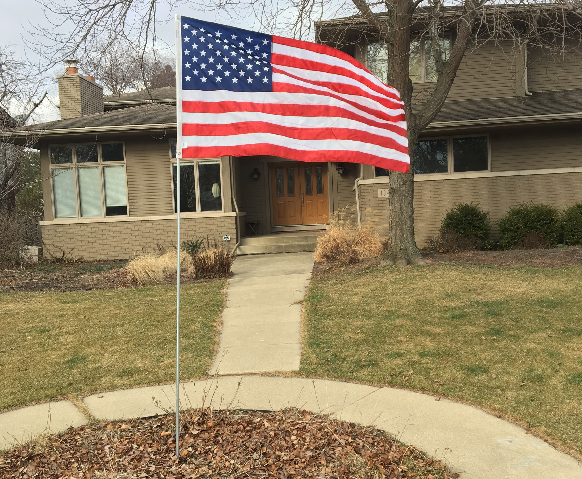

FLAGS ACROSS MUNSTER

What Is Flags Across Munster?

For $25 a year, a Boy Scout from Troop 533 will post and retire a 3x5 flag in your yard on Memorial Day, Fourth of July, and Veterans Day. By participating in Flags Across Munster, you will help instill values, while encouraging and supporting our scouts. You will also be displaying your patriotism when the flag flies proudly in your neighborhood. Your donation will help pay for the scout’s camping trips and activities.

How does it work?

A scout will post and salute the flag in the morning and retire and salute the flag in the evening. We will insert a 12-inch long PVC pipe (1 inch) flush to the ground to secure the flag pole. We will paint the Boy Scout logo on the sidewalk to mark the location. The 3-foot by 5-foot flag will be attached to a ten-foot pole.

How do I subscribe?

We ask for $25, cash or a check payable to Troop 533, when you sign up for your subscription. The scout will take your name, address and phone number/email and will be responsible for the delivery on the three holidays.

What about the flags?

These are U.S. flags, made in the USA from Chicago’s WGN Flag Company, which has been supplying flags and banners for 100 years! Questions? Email: flagsacrossmunster@gmail.com. THANK YOU FOR YOUR SUPPORT!

